Food Truck Project
Due January 21, 2020
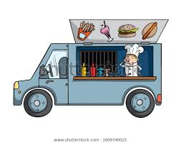

A Truck Themed to the Text
You will be creating a food truck based on the novel you read. Imagine that you are taking it to a world literary conference. Famous authors, publishers, journalists, English teachers, and English students will be eating at the conference, and your truck will represent the novel in every possible way. You will make choices of appearance, theme, and menu based carefully on elements from the text.

Name: _________________________________________________________
Book Title: _____________________________________________________

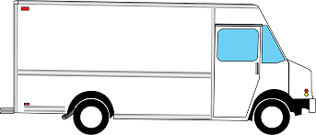
Brainstorm

There are many ways to tie food to a theme. Imagine Harry Potter opened an ice cream truck and created a flavor personalized to everyone he knew. Imagine Katniss Everdeen created a food truck for the capital and created a dish representing each district, all secretly containing a bit of poison as part of the war between the capital and the rebellion. This page is your chance to start brainstorming for the food truck you are going to design. It’s very important to have a clear intention with what you choose, an intention that connects to your reading.
- Start with the type of food. What general type of food will your food truck be serving? Why?
________________________________________________________________________________________________________________________________
________________________________________________________________

- Consider a name for your food truck. Sketch the name and some possible design features on the blank truck above.

- What are some interesting big-picture ways you can connect the truck to the text?
- ___________________________________________________________
- ___________________________________________________________
- ___________________________________________________________
Menu
Your menu is one of the easiest ways to connect your understanding of your book. You will develop five ideas for menu items on the left, then explain how they represent the important elements of the story on the right.

Welcome to our food truck! Today we’re serving:

On the menu: | Why:
On the menu: | Why:
On the menu: | Why:
On the menu: | Why:
On the menu: | Why:
The Crew
Who will be staffing your food truck? Choose characters from the novel that food staff will represent, and again, provide your reasons.

Chef: | Why:
Server: | Why:
Social Media/Marketing: | Why:
Other: | Why:

Other Details

What other details can you use to show your understanding of the novel? These could include the serving ware that the server will use, music the truck might play, the marketing strategies the business will use, the hours of the day that truck will operate, etc. Be creative. List at least three ideas below:

- ________________________________________________________________________________________________________________________________________________________________________________________________
- ________________________________________________________________________________________________________________________________________________________________________________________________
- ________________________________________________________________________________________________________________________________________________________________________________________________
- ________________________________________________________________________________________________________________________________________________________________________________________________
- ________________________________________________________________________________________________________________________________________________________________________________________________

Food Truck Rubric
Required  Elements  _____/20 pts | The project is barely adequate, includes some of the required elements.  (12-13) | This project is missing one or two elements. Additional elements may be incomplete. (14-15) | The project may be missing an element, or one or two elements may be incomplete.  (16-17) | The project includes all required elements completed thoroughly.  (18-20)
Connections to the text  _____/20 pts | Evidence of connection to the text is barely there. This food truck does not reflect an understanding of the text.  (12-13) | The project does not go far enough to explain how the elements of the food truck reflect the text. The analysis is very unclear.  (14-15) | The elements of the project are clearly connected to the test through analysis.  (16-17) | The project is thoroughly connected to the text through careful use of detail and textual analysis.  (18-20)
Overall creativity and effort  _____/10 pts | This project is barely adequate. (5-6) | The project demonstrates limited effort and creativity. (7) | The project reflects solid effort and creativity. (8) | The project is amazing in its creative detail and effort.  (9-10)

